Dataload Data Ingestion Walkthrough & Testing
Guide for testing SmartDev file ingestion from S3 bronze landing to Kafka.

1. What This Test Covers
- Upload an encrypted SmartDev JSON test file to S3 bronze landing.
- Confirm S3 event goes to SQS.
- Confirm Airflow watcher triggers the EMR runner DAG.
- Confirm EMR decrypts/parses the file and publishes Kafka messages.
- Confirm messages appear in the correct Kafka topic.

2. Local EMR Test
This is the manual test path. Use it when you want to test EMR processing directly without depending on Airflow.
- Refer to pages 13 and 14 of John's Tools Guide: BIQ_Analytics_Tools_Guide 2.docx
- Use a renamed encrypted .json.pgp test file.
- Submit the EMR job locally.
- Expected result: EMR job completes with status=SUCCESS and publishes messages to Kafka.

3. Airflow Event-Driven Test
This is the full trigger path we want to validate:
S3 bronze landing -> SQS -> Airflow watcher -> Airflow runner -> EMR Serverless -> Kafka

Step 1 - Merge and deploy latest code
- Push changes to the feature branch under biq-data-load-file-ingestion-processor repo, for example feature/jb-file-ingestion.
- Merge the feature branch into develop.
- Re-run the CI/CD pipeline.
- Confirm the pipeline status is Passed. This means the latest code/config has been zipped and uploaded to S3 for EMR.
Screenshot - CI/CD pipeline passed
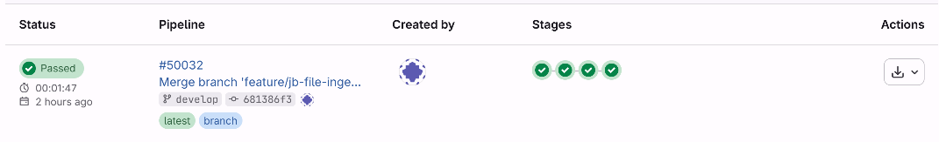

Step 2 - Upload a renamed test file to S3
Upload the PGP encrypted sample file to the correct domain folder under bronze landing.
s3://be-iq-npd-app/smartdev/dev/data-load/bronze/landing/{domain}/
Example for person domain:
s3://be-iq-npd-app/smartdev/dev/data-load/bronze/landing/person/smartdev_person_bronze_landing_20260722T140433.json.pgp
- Always change the file name before uploading the same test file again.
- Person files go to /person/.
- Employment files go to /employment/.
- Relationship files go to /relationship/.
- Sample test files were uploaded to Teams folder Dataload_Sample_Test_Files
Screenshot - S3 bronze landing person folder
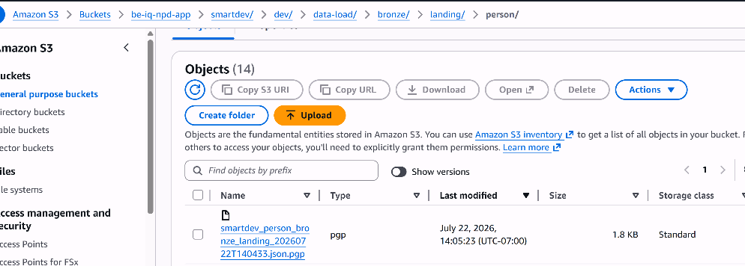

Step 3 - Check Airflow
Open the Airflow UI:
https://biq-analytics-recon-airflow-dev.apps.ocp.npd-biq.idap-oc-usaws.com/dags
- smartdev_sqs_asset_watcher should get a new run after the S3 upload.
- smartdev_pyspark_ingestion_runner should be triggered by the watcher.
- If either run is red, open the latest run and check the task log.
- The run timestamp should roughly match the S3 upload time.
Screenshot - Airflow SmartDev DAGs
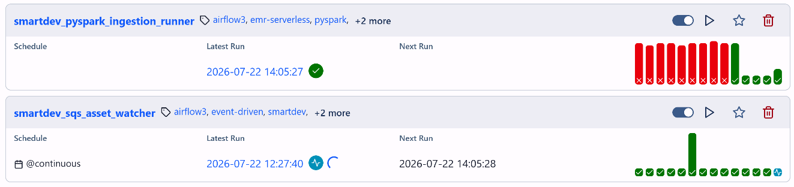

Step 4 - Check EMR Serverless
The Airflow runner should submit a SmartDev EMR job. In the EMR stdout logs, confirm these values:
status=SUCCESS
consumer_status=COMPLETE
processed_sqs_messages=1
processed_s3_objects=1
message_count>0
Current note: ABC control logging is temporarily bypassed if ABC_PG_HOST, ABC_PG_DBNAME, ABC_PG_USER, or ABC_PG_PASSWORD are missing.

Step 5 - Check decrypted file in S3
Confirm the decrypted file lands in the silver decrypted archive folder:
s3://be-iq-npd-app/smartdev/dev/data-load/silver/decrypted/YYYY/MM/DD/
Screenshot - S3 silver decrypted folder
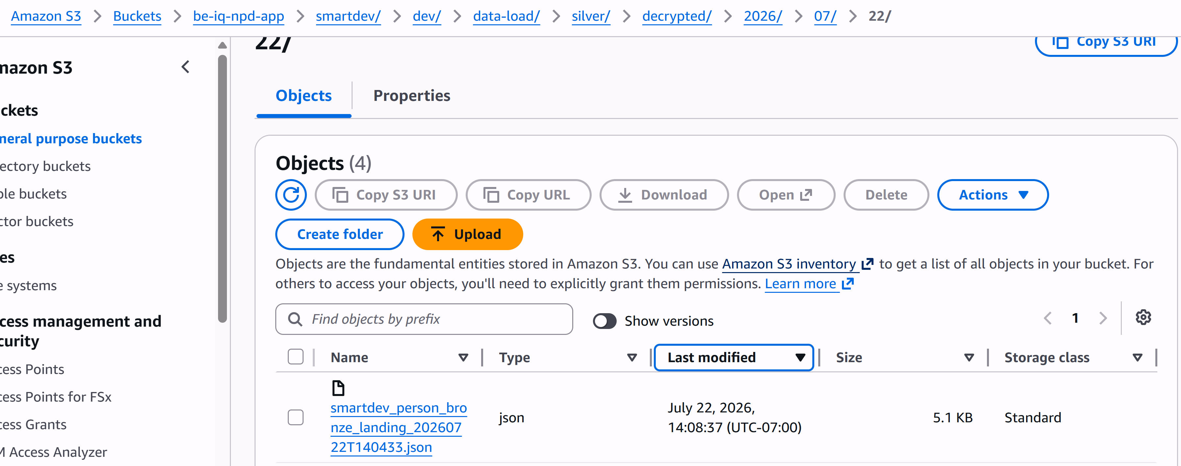

Step 6 - Check Kafka messages
Open Kafdrop and check the corresponding topic.
- Person topic: biq-dataload.person.create
- Employment topic: biq-dataload.employment.create
- Relationship topic: biq-dataload.relationship.create
- If the topic already exists, the job appends messages.
- If the topic does not exist, the job creates it.
- The topic total size should increase by the number of records in the sample file.
Screenshot - Kafdrop topic page
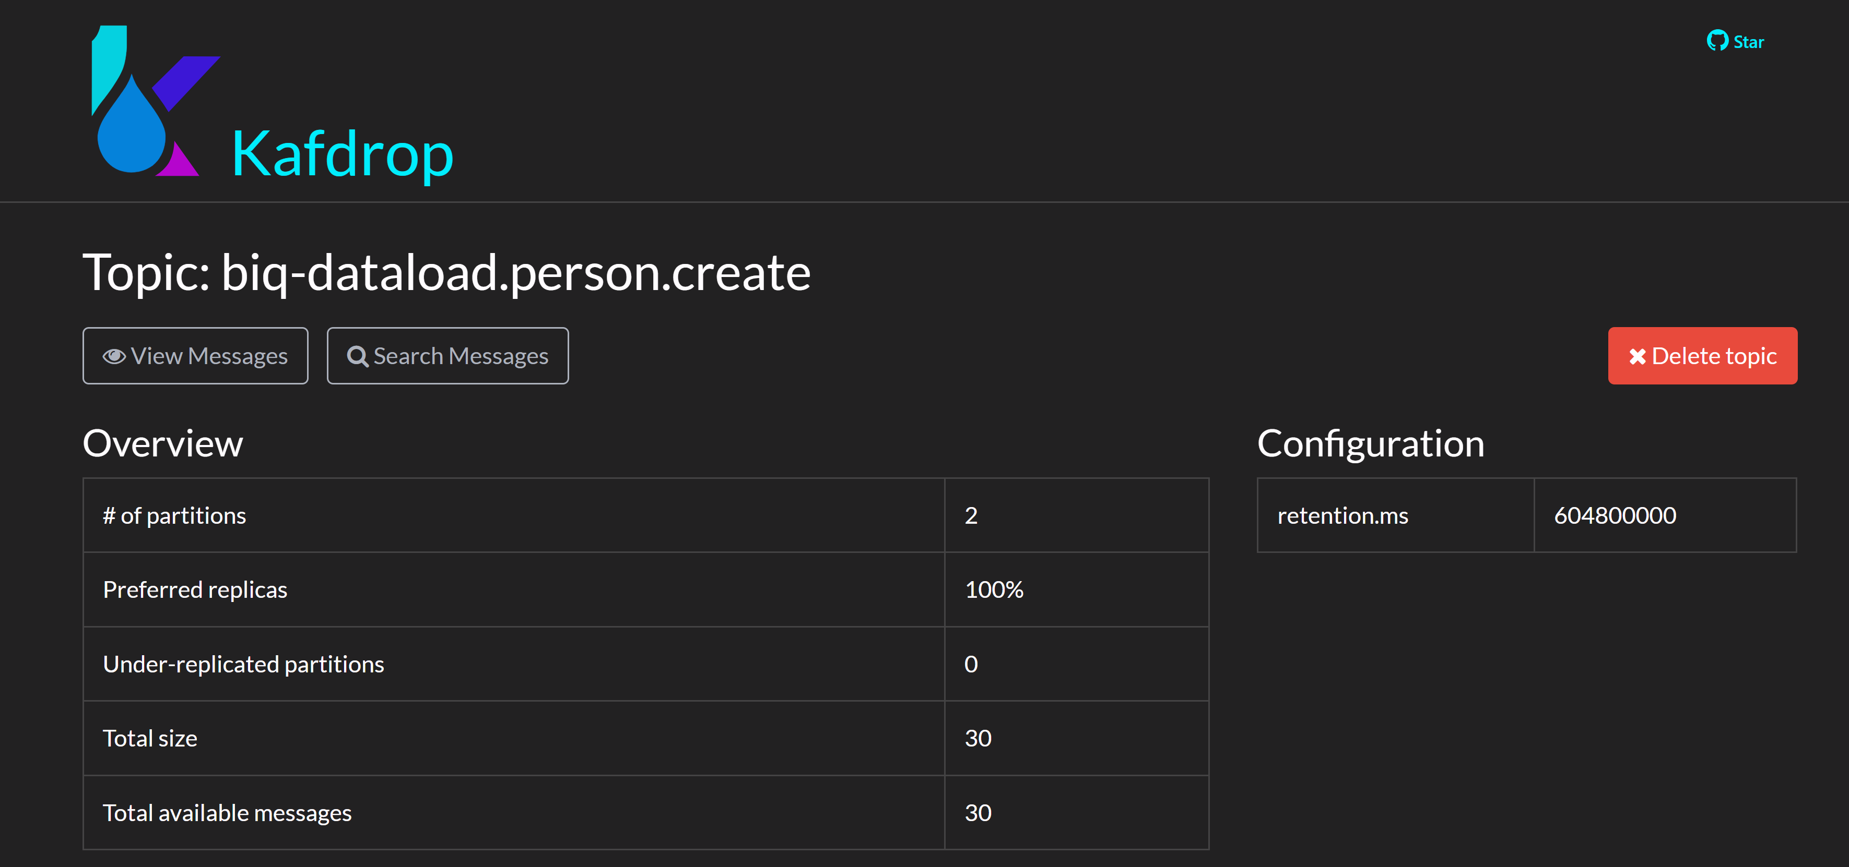

4. Expected Kafka Message Example
Each Kafka message should have an event envelope and a domain payload. Example:
{
"eventId": "evt-000000558382-person-005",
"eventType": "PersonCreate",
"eventVersion": "1.0",
"eventTimestamp": "2026-07-22T21:08:39.013569Z",
"sourceSystem": "SmartDev",
"sourceFileName": "smartdev_person_bronze_landing_20260722T140433.json",
"recordPosition": 5,
"payload": {
"employeeId": "000000558382",
"lastName": "Garcia",
"firstName": "Michael",
"dateOfBirth": "1988-09-06",
"personType": "EMPLOYEE",
"taxIdNumber": "02042f6c72a6b85fe3589b0ed8fea36181c97f2d4a1fe3ef9862844a1f8aa89e",
"taxIdType": "SSN",
"primaryAddressType": "H",
"primaryPhoneType": "P",
"primaryEmailType": "P",
"preferredCommunication": "E",
"addresses": [
{
"addressType": "H",
"streetAddress": "654 Maple Dr",
"city": "Houston",
"state": "TX",
"zipCode": "77001",
"country": "US"
}
],
"emails": [
{
"emailType": "P",
"email": "michael.garcia@example.com"
},
{
"emailType": "W",
"email": "michael.garcia@postal.gov"
}
],
"phones": [
{
"phoneType": "P",
"countryCode": "1",
"phoneNumber": "5715014654"
},
{
"phoneType": "W",
"countryCode": "1",
"phoneNumber": "2027098176"
}
]
}
}

